Lesson plan  The theme of the lesson: My face. |  |  |  | School:
Date: The 21st of February |  |  |  | Teacher’s name:
Class: 1 |  |  |  | Number of present:
Learning objective(s) that this lesson is contributing to: |  | 1.S3 pronounce familiar words and expressions intelligibly  1.L3 recognise with support common names and names of places; recognise the spoken form of a limited range of everyday and classroom words  1.UE6 use demonstrative pronouns this, these that, those to indicate things  1.UE5 use interrogative pronouns which, what, where, how to ask basic questions
Lesson objectives: |  | All learners will be able to:  pronounce parts of the face words appropriately;
Most learners will be able to:
use the structures What is this? It is a … correctly when asking and answering the questions.
Some learners will be able to:
present their project to the class properly.
Language objectives: |  | Learners can:  By the end of the lesson learners will be able to  -work in groups, present their project My face  -use demonstrative pronoun this, special question what
Key words and phrases:
What’s this? It’s a nose! What is this? It is a …..
 |  | Useful classroom language for dialogue/writing:
 |  | Discussion points:
 |  | Can you say why you learn English at school?
 |  | Writing prompts: What is this? It is a …..
Assessment for Teaching |  | Criteria based assessment  Assessment criteria:  Present project work My school things before class intelligibly  Descriptor: A learner  pronounces school object and number words appropriately;  uses the structures What is this? It is a … correctly when asking and answering the questions.  Peer assessment: Oral comments
How to overcome barriers in learning English |  | Pronounce the words distinctly  Encourage learners to repeat the new words several times
Previous learning |  | Activities
Plan
Planned timing | Planned activities (replace the notes below with your planned activities)  What will the pupils learn? How will they learn it?  Suggested Teaching Activities  Active Learning activities |  |  |  |  |  | Resources
Start (Beginning of the lesson)   | Greeting: Teacher greets learners; learners respond to greeting and take their places. Dividing into subgroups: Teacher divides learners into subgroups using the moon, the sun and the star Revising the previous lesson: Craftwork Learners listen to and sing the song Touch your ears! together with the teacher.  Warming up: Brainstorming: Teacher asks the learners a question: How do you think what words come to your mind when you hear the word “my face”? Learners exchange ideas with one another. Any idea is accepted |  |  |  |  |  | Cards with pictures of the moon, sun and star
Middle (of the lesson) | W) Teacher presents new lesson with the help of pictures and slide on the laptop. Asks pupils to repeat them after her several times. Make pupils to pronounce them correctly.  G) Teacher gives the whole face to each group and asks pupils to stick the parts of the face on it. Three groups will stick the pictures and try to show the whole face.  I) Teacher asks pupils to find out new words of today’s lesson. She gives them sheets with task as following:  H A I R B E Y E S  C A R T E A N S I  H A T R B R T O R  U P Q P E S E N D  M O U T H N O S E  W) Learners sing the song: Head.. Shoulders. Knees and toes!  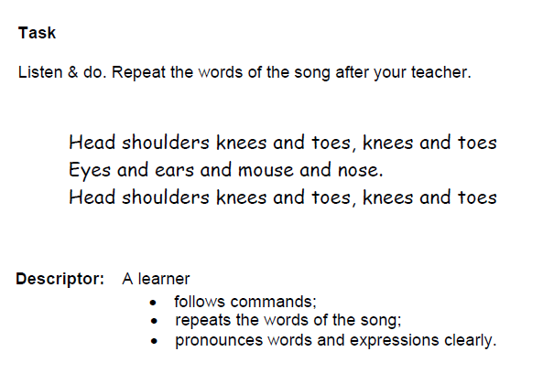  I)Teacher calls one pupil from each group and command: Touch your ears!  Touch your hair!  Touch your mouth!  Touch your nose! |  |  |  |  |  | picture dictionaries, posters, stickers, Student’s book1, Activity Book 1
End (of the lesson) | Reflection: Peer assessment: Oral comments  - What have you learnt today?  - Which task do you like?  Learners make comments about the lesson orally. Teacher asks learners to show the colours of traffic light on their hands.
Additional information:
Differentiation - how do you plan to give more support? How do you plan to challenge the more able learners? |  |  | Assessment - how are you planning to check learners’ learning? |  | Cross – curricular links health and safety check ICT links  Values links
Reflection  Were the lesson objectives / learning objectives realistic?  What did the learners learn today?  What was the learning atmosphere like?  Did my planned differentiation work well?  Did I stick to timings? What changes did I make from my plan and why? |  |  | Use the space below to reflect on your lesson. Answer the most relevant questions from the books on the left about your lesson.
Summary evaluation
What two things went really well (consider both teaching and learning)?
1.
2.
What two things would have improved the lessons (consider both teachings and learning)?
1.
2.
What have learned from his lesson about this lesson about the class or individuals that will inform my next lesson?

